**Step one – Rename the Kodi Addon**

Download the Addon Playlist Loader  
[**Download**](http://www.aerialview.tv/app/PlayListLoader.zip)

We will be editing a few lines of code and the best program for this is Notepad++  
[**Download Notepad++**](https://notepad-plus-plus.org/download/v6.9.2.html)

Open the downloaded zip file and extract the folder inside to your desktop.  
Rename the folder to **plugin.video.myapp** (the myapp part your can edit to suit)  
Open the folder and open the file **addon.xml**

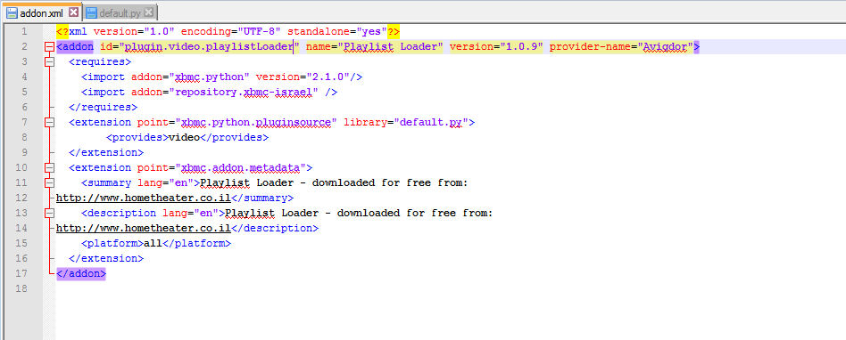

In this file we need to remove all connections to the wording "Playlist Loader"  
Only editing inside the quotation marks.

Line 2: Change plugin.video.playlistloader to the same name you have used for the addon folder. We used **plugin.video.myapp**.  
Change the name ="**Playlist Loader**" to anything you like, update the version number to **99.0.0** and edit the **provider name** to anything you like.

Line 11 & 12: Edit the summary to suit.  
Line 13 & 14: Edit the description to suit.

It should now look like this

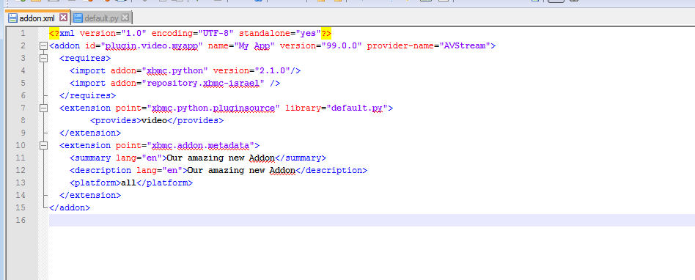

Save your document.

**Step Two – Edit the default.py, common.py & settings.xml files**

Now we need to do a similar thing with the default.py file.  
Open **default.py**

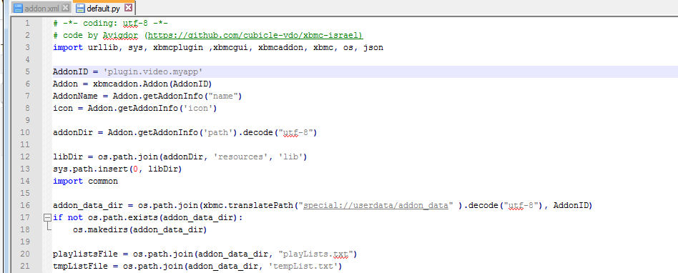

Line 5 again edit the AddonID so it has the same name as your addon folder we used **plugin.video.myapp**

Save your document.

Open the resources folder and open the file settings.xml.  
In the two lines 3 & 4 change the **plugin.video.playlistloader** again to your folder name.

Save your document.

Last but not least we need to edit the same texts in the **common.py** file.  
This file is **located in the lib folder**We need to edit the text in line 3 the same as we have previously.

Save your document.

**Step Three – You now have your own Addon**

Let's fire it up in Kodi and make sure everything is working.

Move the your edited addon folder in to your Kodi Addons directory.  
You can find your Kodi directory **C://Users/yourPCname/AppData/Roaming/Kodi/addons**   
(remember to make sure you can view hidden files and folders)

Just drag the folder and its contents in to the addons folder and launch Kodi.

Go in to Settings > Add-ons > Video Addons

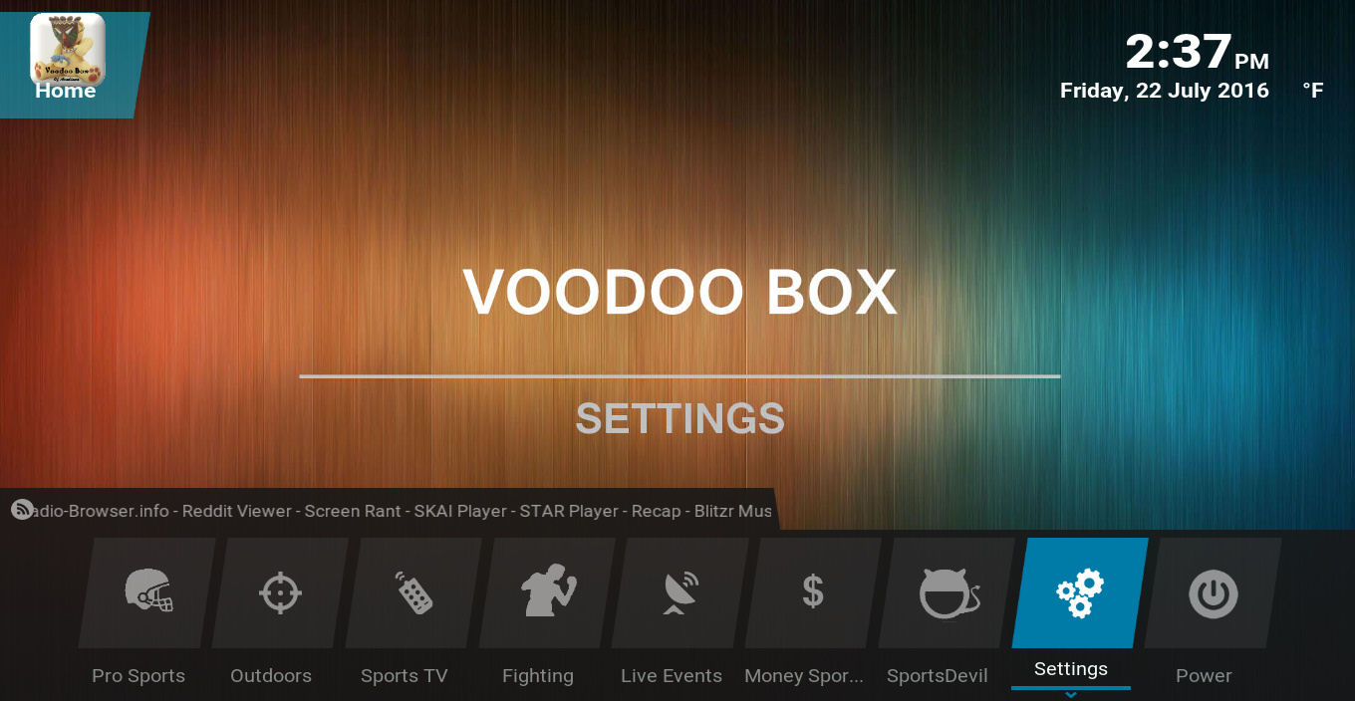

**Kodi Sports Build we made for the VOOBOX team using the eminence zeev skin.**

In your list of addons you should now see your edited version of Playlist Loader. It will be named whatever you called it in step one. Ours is called My App.

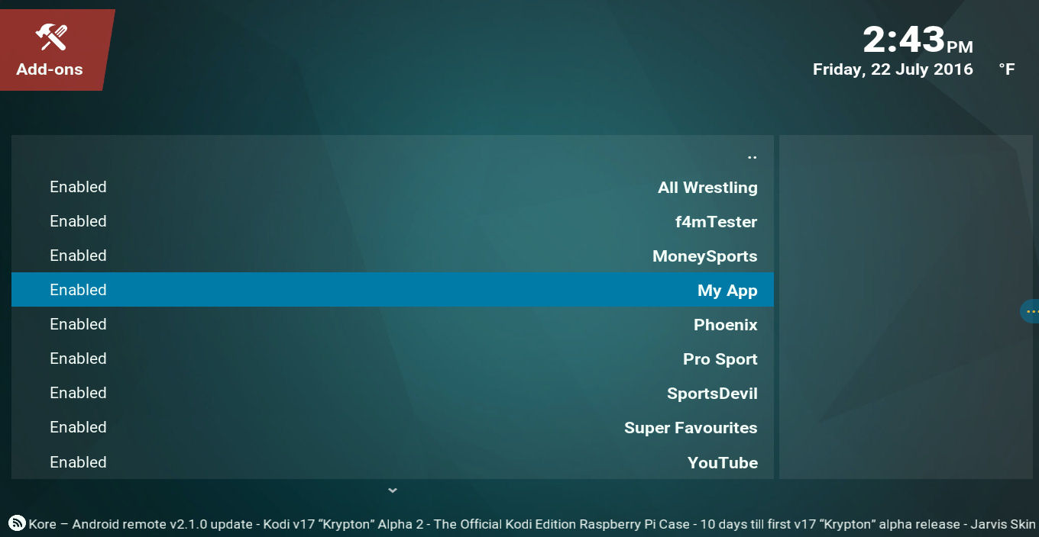

Great work, you now have your own Addon.  
We could edit the Addon even further but for now it is not required for what we will be using it for.

Let's make some playlists for our Addon.

**Step Four – Getting, Testing and Creating.**

This is the fun part.

What we are going to do now is find some m3u playlists, create our own and test our playlist.

We use a few providers for our playlists. You will find the most reliable list on forums and most of them require you sign up.

To get you started here is one of our favorites and we will be using them in this guide.  
[**http://linuxsat-support.com/forumdisplay.php/591-IPTV-Channel-Lists-rtmp-m3u-Playlist**](http://linuxsat-support.com/forumdisplay.php/591-IPTV-Channel-Lists-rtmp-m3u-Playlist)

Scroll through the threads to find a playlist that you like the look of.

The rule of thumb here is the most recent post will have the best chance of working. Always go to the last post in the thread. The poster my require you to click "Thanks" for the post before you can download your playlist.

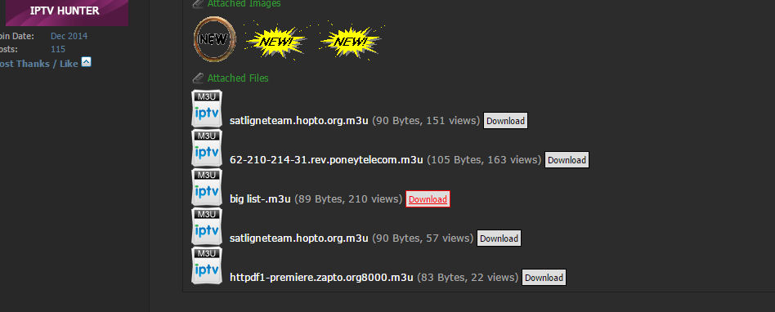

We will try and get Sky Sports channels.  
Click download on your choice to get your m3u file.

Now we need to test it.   
[**Download VLC player to your PC**](http://www.videolan.org/vlc/index.html)

Once installed locate your downloaded m3u playlist.  
Right click **"Open with"** and use Notepad++. Keep the editor open for now.  
***When we opened the big list file for editing we noticed only 1 link, by double clicking that link in the editor the real m3u playlist was downloaded and this is the file we will be using. Worth remembering.***

Go to the downloaded m3u playlist and this time **drag the file over the VLC player icon** to open the and test the live feeds.

You should have the VLC player and notepad++ editor windows both visible.  
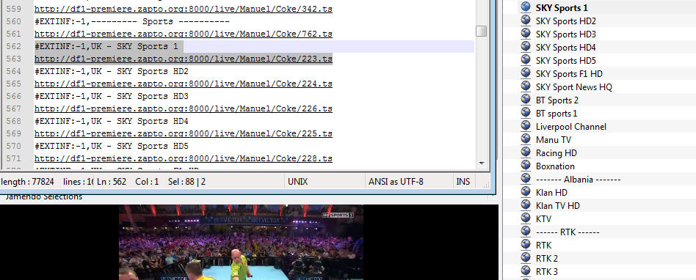

 The playlist in VLC player and the list in notepad will resemble one another.

In the editor each channel takes up 2 lines. The first line gives the channel a title and the second link is the link to were the channel is. Line 1 of all m3u files will start with the syntax **#EXTM3U.**

We will only be removing none working channels and if required renaming the working channel names.

As you can see we found a working Sky Sports live feed in VLC player and found it in the editor. All we need to do now is delete everything else from the playlist so we are only left with the channels that either work or that we want.

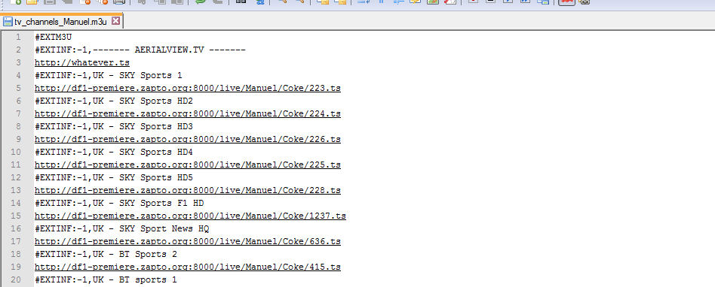

This is what we are left with in the editor.  
Just always remember to leave line one as **#EXTM3U**  
We have used lines 2 and 3 to create a header for a channel list. Line 3 is just a fictitious URL so that if the user clicks it nothing will happen.

Save the document.

**Step Five – Uploading to Cloud Storeage**

Visit **www.github.com** and sign up for a free account

Once you have activated your sign up e-mail select add repository, call it what you like.  
Add a README file.

Edit the title of README.md file to live.m3u

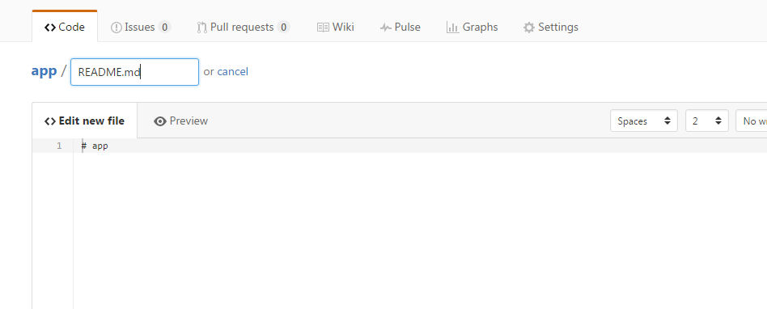

In the text window paste in your M3U playlist from notepad++

Scroll down and select commit changes.   
This saves your document.  
Once saved select RAW from the top right options. When the window opens copy the contents of your browsers address bar it should look like

**https://raw.githubusercontent.com/yourLOGINname/respositoryNAME/master/live.m3u**

**Step Six – Add the playlist in to your Kodi Build**

Launch Kodi and open your Addon

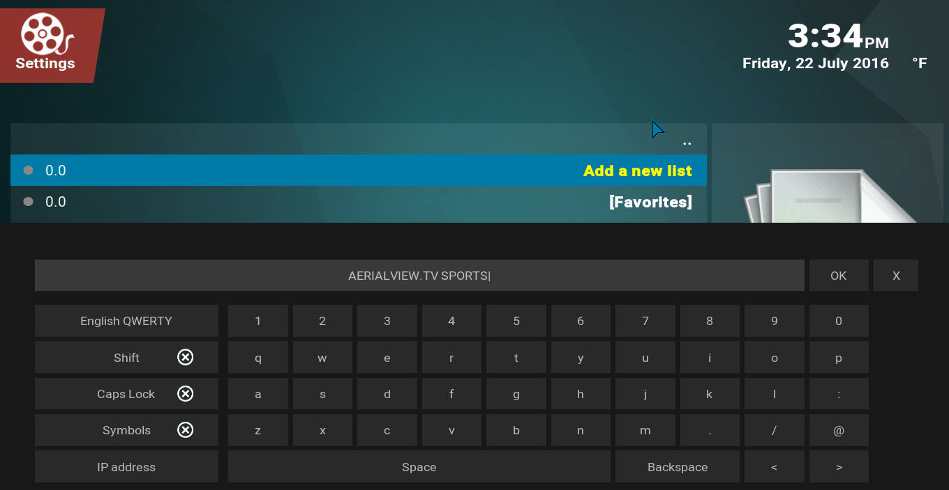

Select Add new list and in the text window give your channel list a name. Another window will open once you select DONE.

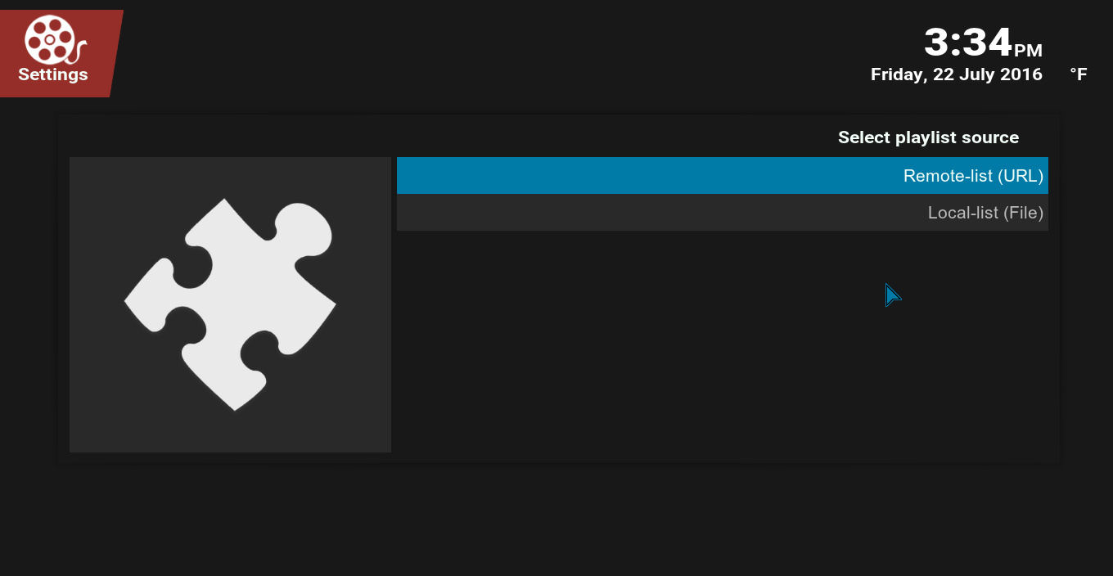

Select Remote-list (URL) and in the next text window paste in the URL from GitHub. Press done.  
The next two options give you the chance to add some remotely stored images to the playlist, personally I wouldn't waste my time on it but the options are there if you wish to use them.

You will arrive back to Add-on home screen and if everything went well you will see your playlist in the options.

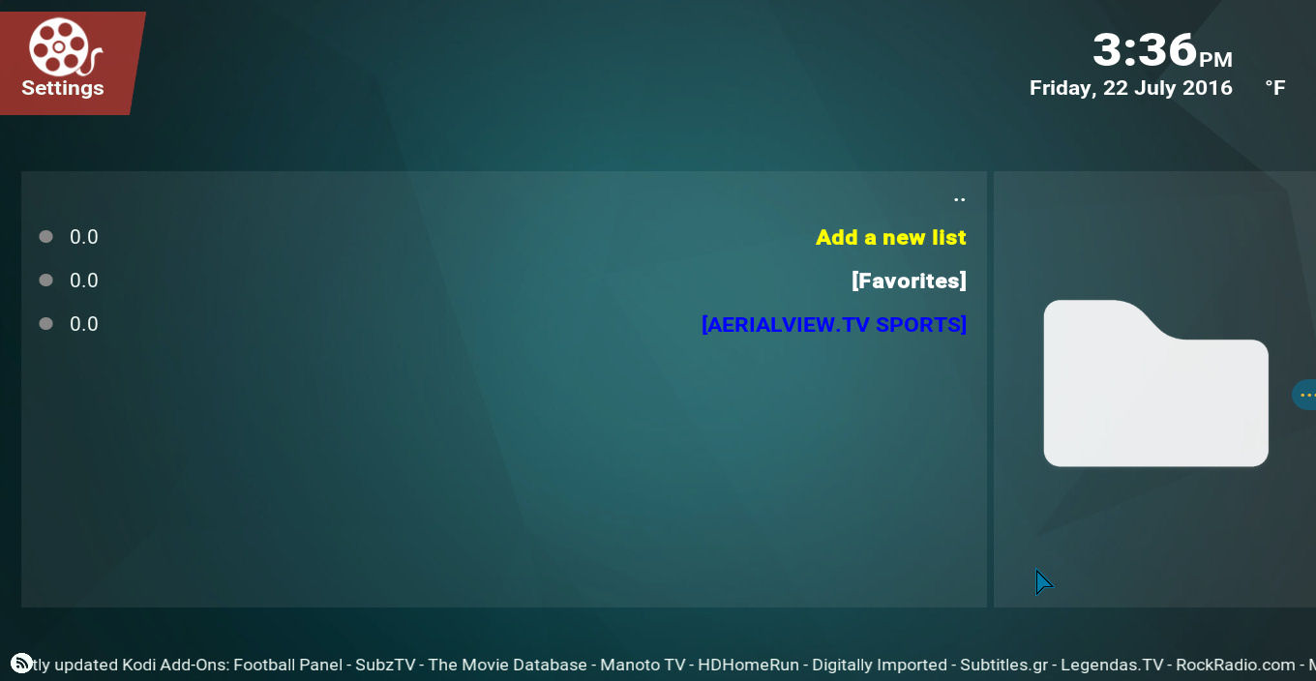

Click on your playlist to see your channels..

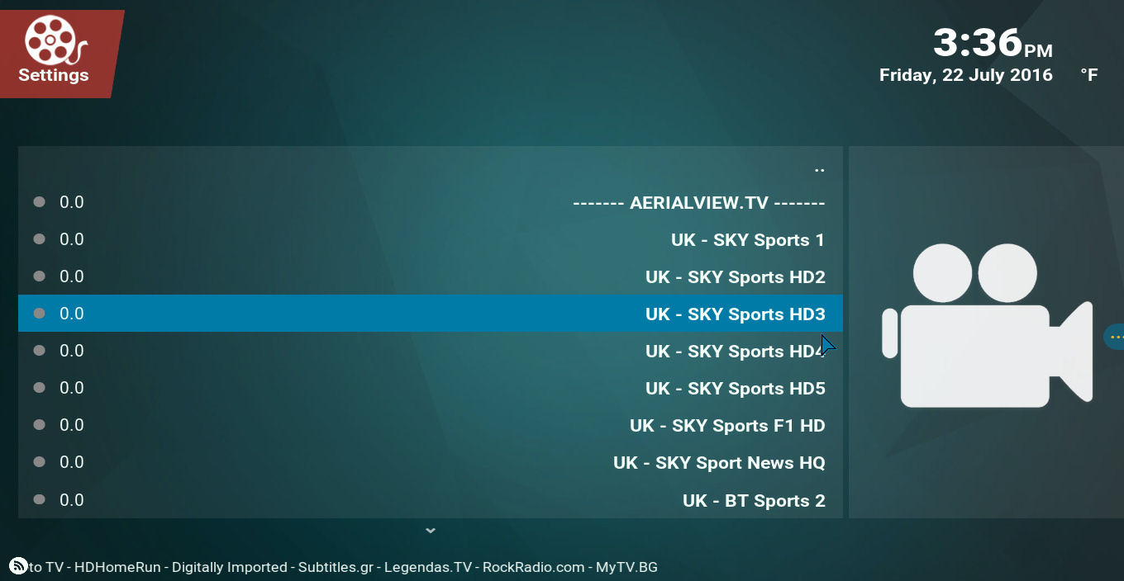

Select a channel and watch it play from the location in your GitHub.

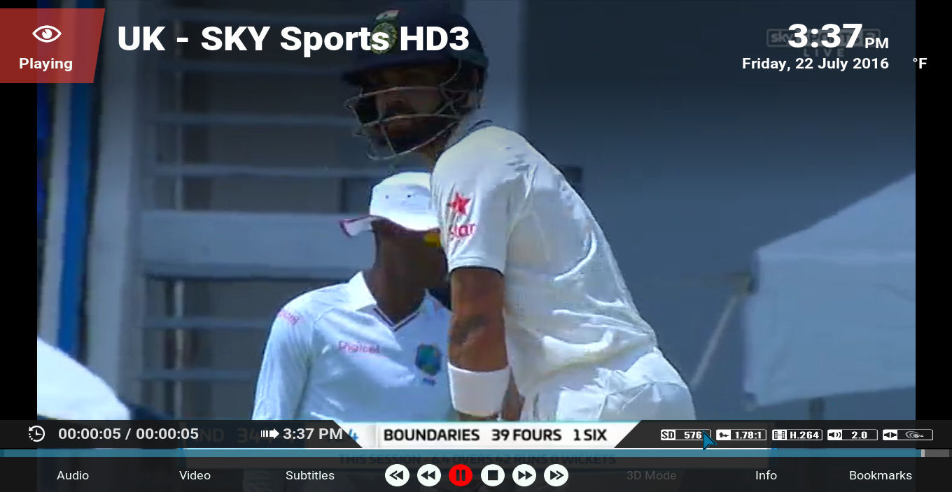

Well done. You have your very own Kodi Add-on that you can update and edit remotely so it changes in real time for your users.

**Congratulations – You’ve just earned your ctrl+c ctrl+v developers badge**

You have your own addon that you can control the content from your GitHub account.  
We tend to make a favorite link to the channel list so that the user opens directly in to the list of channels from the build.

Play around with it and have some fun.